**Task 2: Virtualization, Installation of virtual machine software and installation of operating system on virtual machine.**

**VIRTUALIZATION**

Linux is an open-source operating system (OS) based on Unix. It is known for its robustness, security, and flexibility, making it a popular choice for servers, desktops, and embedded systems. One of the key features of Linux is that its source code is freely available, allowing anyone to view, modify, and distribute it.

**Key Features of Linux:**

* **Open Source**: The source code is freely available for modification and distribution.
* **Security**: Known for its strong security features, making it less vulnerable to malware and viruses.
* **Stability**: Highly stable and reliable, suitable for running critical applications.
* **Flexibility**: Can be customized for different uses, from desktops to servers to embedded systems.
* **Community Support**: Strong support from a global community of developers and users.

**Popular Linux Distributions**

Linux distributions (often called "distros") are variations of the Linux OS that come with different sets of software and features. Here are some of the most popular ones:

1. **Ubuntu**
   * **Description**: One of the most user-friendly and widely used Linux distributions, especially popular for desktops and beginners.
   * **Features**: Regular updates, strong community support, extensive software repositories.
   * **Use Cases**: Desktops, laptops, servers.
2. **Fedora**
   * **Description**: Known for its cutting-edge features and strong backing from Red Hat.
   * **Features**: Up-to-date software, emphasis on open-source technologies.
   * **Use Cases**: Desktops, developers, and those who prefer the latest features.
3. **Debian**
   * **Description**: A highly stable and versatile distribution, serving as the base for many other distros, including Ubuntu.
   * **Features**: Extensive package repository, strong emphasis on free software.
   * **Use Cases**: Desktops, servers, and development environments.
4. **CentOS**
   * **Description**: Community-driven, free alternative to Red Hat Enterprise Linux (RHEL).
   * **Features**: High stability, enterprise-grade features, long-term support.
   * **Use Cases**: Servers, enterprise environments.
5. **Arch Linux**
   * **Description**: Known for its simplicity and customization, targeting advanced users.
   * **Features**: Rolling release model, minimalistic approach, user-centric customization.
   * **Use Cases**: Desktops, advanced users who prefer to build their systems from scratch.
6. **Mint**
   * **Description**: Aimed at providing a comfortable and user-friendly experience for beginners.
   * **Features**: Easy installation, pre-installed software, based on Ubuntu.
   * **Use Cases**: Desktops, new Linux users.
7. **openSUSE**
   * **Description**: Known for its powerful tools and strong community support.
   * **Features**: YaST (Yet another Setup Tool) for easy system configuration, strong emphasis on stability.
   * **Use Cases**: Desktops, servers, development environments.

**Minimum Hardware Requirements:**

**Kali Linux**

* **Processor**: 2 GHz dual-core
* **RAM**: 4 GB (2 GB for virtualized installs)
* **Storage**: 25 GB (8.6 GB for minimal install)
* **Display**: 1024x768 resolution
* **Other**: CD/DVD drive or USB port for installer media, internet access is helpful

**Steps to install kali linux using virtual box:**

* **Download Virtualization Software**:  
  Install a virtualization program like **Oracle VM VirtualBox** or **VMware Workstation** on your computer.
* **Download Linux ISO**:  
  Download the ISO file for your preferred Linux distribution (e.g., **Kali linux**).

**Steps of installation of virtual box:**

**Step 1: Click Download VirtualBox:** It's a blue button in the middle of the page. Doing so will open the downloads page.

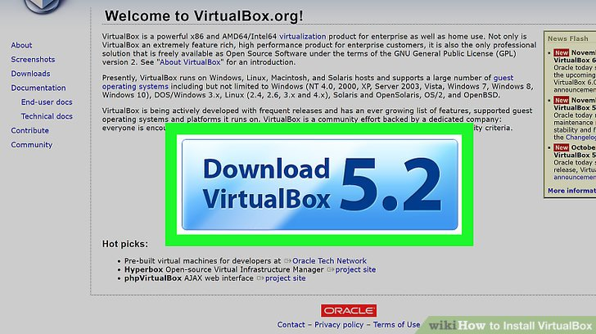

**Fig 1. Download virtual studio**

**Step 3**: You'll see this link below the "VirtualBox 6.1.14 platform packages" heading. The VirtualBox EXE file will begin downloading onto your computer.

**Step 4: Open the VirtualBox EXE file:** Go to the location to which the EXE file downloaded and double-click the file.

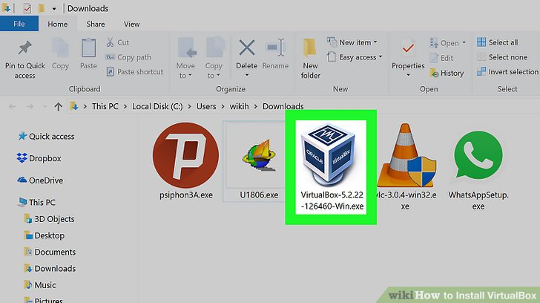

**Fig 2. Open virtual box setup file**

**Step 5:** install the exe file.

When you open virtual box it will look like as shown below:

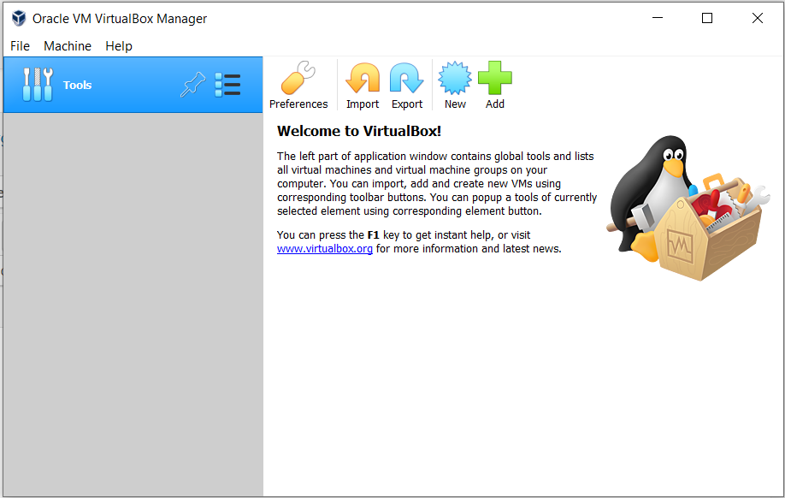

**Fig 3.Home page of virtual box**

(a) Launch **VirtualBox Manager** and click the **new** icon.

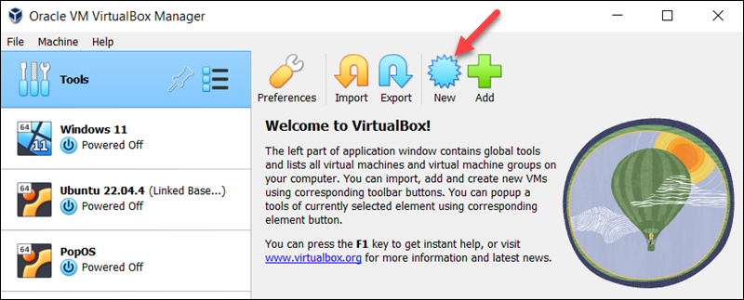

**Fig 4. click the new icon**

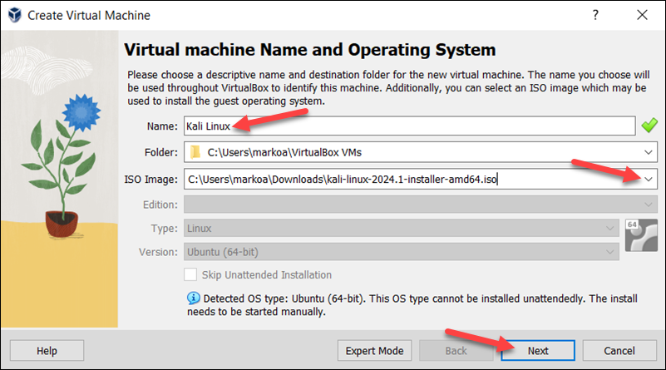(b) Specify a name for the VM and provide the path to the ISO image. Select **Next**.

**Fig 5. Specify a name for the VM and provide the path**

(c) Select the amount of memory and the number of VIRTUAL STUDIO to allocate to the VM.

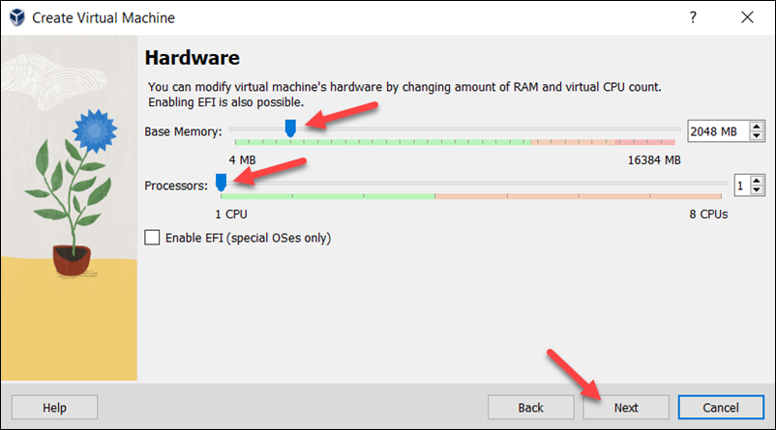

**Fig 6. Select the amount of memory**

(d) Create a virtual hard disk for the new VM. The recommended hard disk size is at least **25 GB**. Alternatively, you can use an existing virtual hard disk file or decide not to add one. Click **Next** to proceed to the next step.

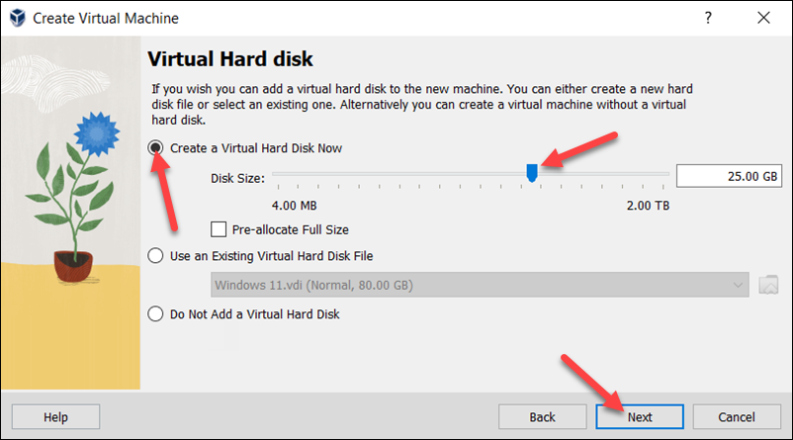

**Fig 7. Create a virtual hard disk for the new VM**

(e) Review the new VM setup on the **Summary** page. Select **Finish** to create the virtual machine.

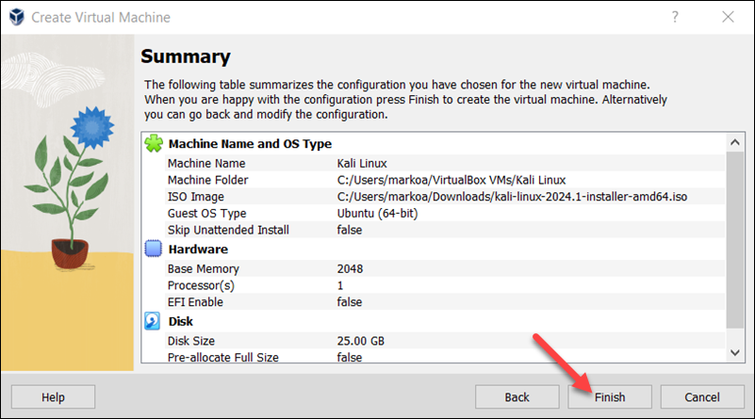

**Fig 8. Select Finish to create the virtual machine**.

**Step 3: Configure the Start VM**

* Before starting the VM and beginning the installation process, follow the steps below to perform additional adjustments on the VM:

(d) Click **Start** to begin installing Kali Linux.

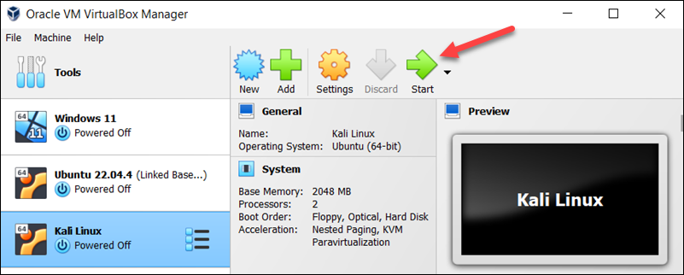

**Fig 9. Start to begin installing Kali Linux**

**Step 4: Perform Initial Configuration**

* When the new VM is started, the Kali Linux installer menu appears. Start the installation procedure by following the steps below:

(a) Select the **c** option.

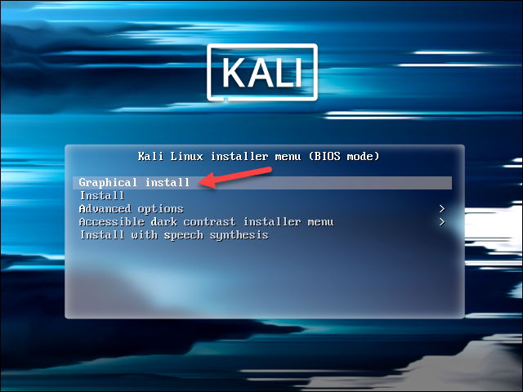

**Fig 10. Start to begin installing Kali Linux**

* **Perform Initial Configuration**

(b)Choose the system's **default language**, which will also be used during installation.

(c)Find and select your **country** from the list or choose **other**.

(d)Decide which **keyboard mapping** to use.

**Step5: Configure Host, User, and Time Zone**

* The following installer steps set up the hostname and domain of the system and configure the user:
* (a)In the **Configure the network** section, enter a **system hostname**.

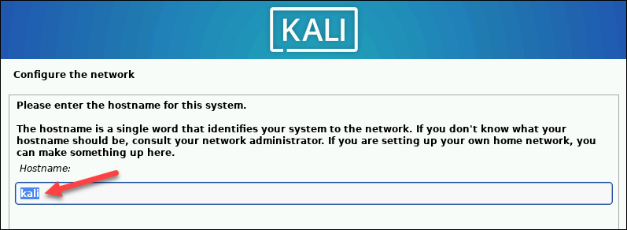

**Fig 11. Enter a system hostname**

(b) Type a **domain name** that the OS will use to identify the VM within a network. Specifying a domain name is not necessary if the VM is not part of an extensive local network.

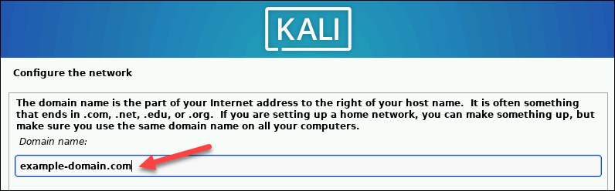

**Fig 12. Type a domain name**

(c) Create a **user account** by providing the user's full name and username.

(d) Create a password for the user account.

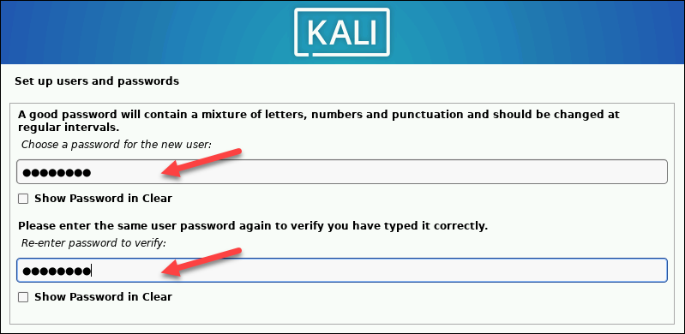

* Select the correct **time zone** from the available options.
* **Step 6: Create Hard Disk Partitions**
* Proceed with the following steps to create a bootable partition on the virtual hard disk:

(a) Select how to partition the hard disk. The default option is Guided - use entire disk.

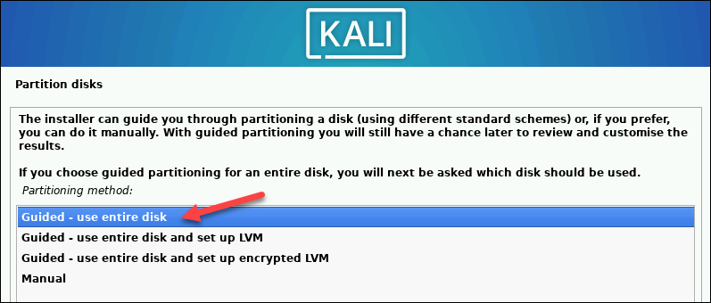

**Fig 12. Create Hard Disk Partitions**

* Select the disk you want to use for partitioning. The only available option is the disk created during the VM creation.
* Select the **partitioning scheme**. The default option is All files in one partition.

(d) The wizard provides an overview of the configured partitions. Ensure that the **Finish partitioning and write changes to disk** option is selected.

(e) Confirm the choice by selecting **Yes** on the next screen.

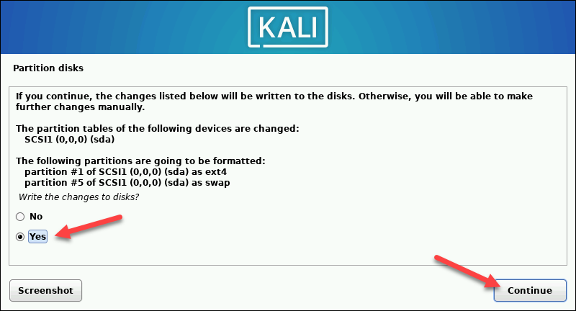

**Fig 13. Finish partitioning and write changes to disk**

**Step 7: Customize Kali Linux Installation:**

* After installing the system's core, Kali enables users to customize the OS further. Choose the components to install by executing the following steps:

(a) Select the desktop environment and the tools you want or click **Continue** to proceed with the default options.

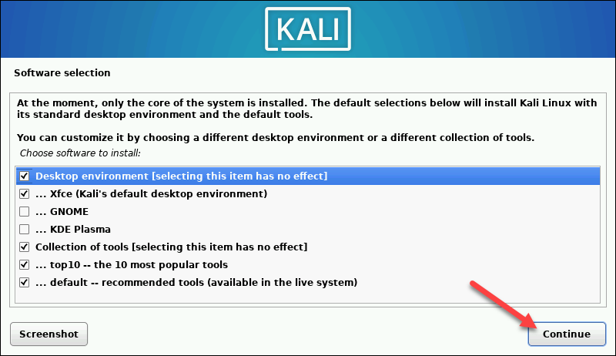

**Fig 14. Customize Kali Linux**

(b) Select whether you want to use a network mirror.

(c) If you use an **HTTP proxy**, enter the necessary information. Otherwise, leave the field blank.

(d) Install**the GRUB bootloader** on the hard disk. Select **Yes** and **Continue**.

(e) Select a bootloader device to ensure the newly installed system is bootable.

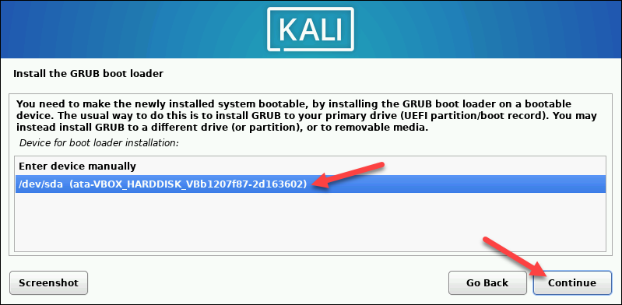

**Fig 15.Install the GRUB bootloader**

**When Kali finishes installing, the *Installation is complete* message appears.**

(f) Click **Continue**to reboot your VM. After rebooting, the Kali login screen appears.

(g) Enter the username and password created in the previous steps.

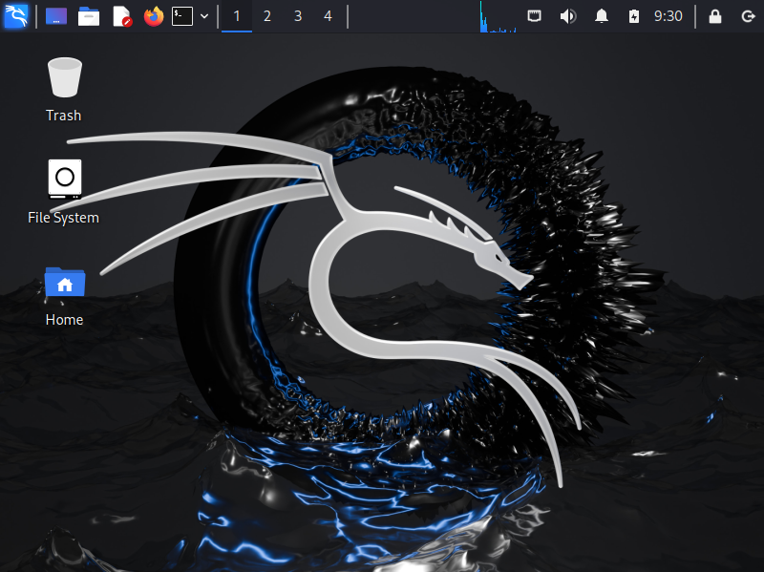

**Fig 16.The Kali Linux desktop appears on the screen**.